
What to Expect after Your Child Has Ear Tube Surgery
What is ear tube surgery?
For children who get lots of ear infections, or have fluid behind their eardrums that does not go away,
Your provider may recommend that they have tubes placed into their eardrum to drain this fluid and
Decrease the number of ear infections that occur. The name for this surgery is myringotomy tube
Placement or tympanostomy tube placement. This is an outpatient surgical procedure that takes about
30 minutes and is performed under general anesthesia. The patient goes home about one hour after surgery.

What are ear tubes?

Ear tubes are tiny and made of lightweight plastic. They help prevent ear infections and drain out fluid
If an ear infection does occur. The procedure causes about 20 minutes of discomfort, after which the tubes do not hurt, and your child will probably not even know they have them. Depending on what kind of tube your doctor chooses to put in, they usually stay in the ear for 6 months to 2 years, sometimes longer. Ear tubes will usually come out of the eardrum on their own, but rarely your doctor must remove them.

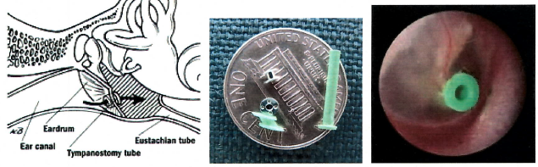

What do I need to do after my child goes home after surgery?

Most children recover very quickly after ear tube surgery. Here are some important things to know:
- Eating and drinking: Children can go back to a normal diet the day of surgery.

